BRIO Data Analytics Reports – Scope Document

Project Information
- Project Name: Data Analytics
- Project Manager: Nandan Kishore
- Stakeholders: Sara Wild, Marcus Bryan, Woody Pryor
- Report Request Date: [Enter date] to be determined after further analysis and planning after requirements gathering
- Desired Delivery Date: [Enter desired delivery date] to be determined after further analysis and planning after requirements gathering

Report Priority, Overview & Purpose
- Daily Occupancy Report
- Headcount Report
- Operating Ratio Report
- Payer Mix Report
- HR Recruitment Report
- Hospital Readmissions Report
- HR Budget to Paid Earnings
1. Daily Occupancy Report
This report provides detailed insights into bed occupancy, discharges, and census status for all communities within BRIO Living Services. It is designed to help administrators and staff monitor and manage occupancy rates, ensuring efficient use of resources and optimal patient care.
2. Headcount Report
The Headcount Report provides a comprehensive view of the number of employees within the organization. It includes data on new hires, terminations, and current headcount by department, role, and location. This report is crucial for HR and management to track workforce trends, plan for future staffing needs, and ensure that the organization is adequately staffed.
3. Operating Ratio Report
The Operating Ratio Report offers insights into the financial performance of the organization by calculating key financial ratios. These ratios help assess the efficiency and profitability of the organization’s operations. Key metrics included in this report may cover cost-to-revenue ratios, profit margins, and other financial indicators crucial for strategic planning and decision-making. Stakeholders can use this report to identify areas for improvement and optimize operational processes.
4. Payer Mix Report
The Payer Mix Report provides an analysis of the revenue generated from different payer sources, such as Medicare, Medicaid, private insurance, and self-pay. This report is essential for financial planning and management, as it helps the organization understand the distribution of its revenue streams and identify potential areas for diversification or improvement. By tracking changes in the payer mix over time, the organization can make informed decisions about contracting, pricing, and service offerings to maximize revenue and ensure financial stability.
5. HR Recruitment Report
The HR Recruitment Report tracks the effectiveness of the organization’s recruitment efforts. It includes data on the number of job postings, applications received, interviews conducted, and new hires made. This report helps HR professionals and management assess the efficiency of the recruitment process, identify bottlenecks, and make data-driven decisions to improve recruitment strategies. The report can also highlight trends in the labour market and provide insights into the organization’s competitiveness in attracting top talent.
6. Hospital Readmissions Report
The Hospital Readmissions Report monitors the rate of patients readmitted to the hospital within a specific period after discharge. This report is critical for assessing the quality of care provided and identifying areas where improvements are needed to reduce readmission rates. By analysing readmission data, healthcare providers can implement targeted interventions, improve patient outcomes, and reduce healthcare costs. The report can be generated at various intervals to track progress and measure the impact of quality improvement initiatives.
7. HR Budget to Paid Earnings
The HR Budget to Paid Earnings Report compares the organization’s budgeted HR expenses to the actual paid earnings. This report provides valuable insights into the organization’s financial performance and helps identify discrepancies between planned and actual expenditures. By analyzing this report, management can make informed decisions about resource allocation, budget adjustments, and cost-saving measures. The report also helps ensure that the organization remains within its budgetary constraints and achieves its financial goals.
Frequency:
Following are schedules for data load frequency and the final report to be refreshed.

REPORT | Job Load | QuickSight Visualization Refresh
Daily Occupancy | Development team will decide working backwards to ensure QS is loaded at 5AM | Daily – 5AM (data to present as on day prior)
Headcount Report | Follow same rules | Weekly
Operating Ratio Report
Payer Mix Report |  | Daily
HR Recruitment Report | Follow same rules | Weekly
Hospital Readmissions Report |  | Daily
HR Budget to Paid Earnings | Follow same rules | Weekly

Audience:
[Who will be the primary audience for the report?] – Request Sara to share the usernames list. Need 2 separate list (i) Users performing UAT (ii) Users who will have access to this dashboard. Not urgent since, some of the users may change by the time we finish developing the report. However, we can have minimal information before we could get started.

REPORT | User Acceptance Test (UAT) User List | Business User on Production environment
Daily Occupancy
Headcount Report
Operating Ratio Report
Payer Mix Report
HR Recruitment Report
Hospital Readmissions Report
HR Budget to Paid Earnings

Data Requirements
Data Sources: The SOW defined as per the Phase-I which will entail ingestion from
  - PointClickCare (PCC)
  - SAGE
  - PCO for PACE
  - ADP
  - MatrixCare for Home Health and Hospice
  - We need access to budget details/file. Any other data sources have to be specified by Sara.

Report Content
- Key Metrics:

REPORT Name | Key Metrics & Report Visualization | Calculations
Daily Occupancy | Current Occupancy | PCC:  Exclude Second Occupant/Payer Payer Type  Count if Census code = Active (A), Discharged Paid (DP), Expired Paid (EP), Hospital Paid (HP), (Hospital/ Therapeutic Leave (LV), Private Pay Reserve (PPR), Room Reserve (RR)  PACE:  Total Participants
 | Current Occupancy % | Current occupancy/ Current Available (number of rooms)  Bed numbers are named as “A” & “B”  Do not include the 2nd beds occupancy in the calculation  Should not include the budget associated to the 2nd bed. Budget occupancy should be calculated for 1st bed (A) only.  In budget file, you will
 | Current In-Service Days | # days
 | Current Available | Fixed per Budget Spreadsheet
 | YTD Occupancy | Sum current occupancy
 | YTD Budget Occupancy | Current Available
 | YTD Resident Days
 | YTD In Service Days
 | YTD In Service Days Budget
 | YTD Budget Resident Days
 | Occupancy Pivots (Visualization)
 | Occupancy by Level of Care (including YTD)
 | Revenue
 | Admissions, Discharges, Vacancy
Operating Ratio Report | Occupancy Summary
 | Operating Ration
Headcount Report | Turnover
 | Monthly
HR Recruitment Report
Hospital Readmissions Report
HR Budget to Paid Earnings
PayerMix

- Visualizations: [Describe the type of visualizations needed (e.g., bar charts, line graphs, pie charts)]

- Filters: [Specify any filters to be applied to the data]

Technical Details & Requirements
- Process:
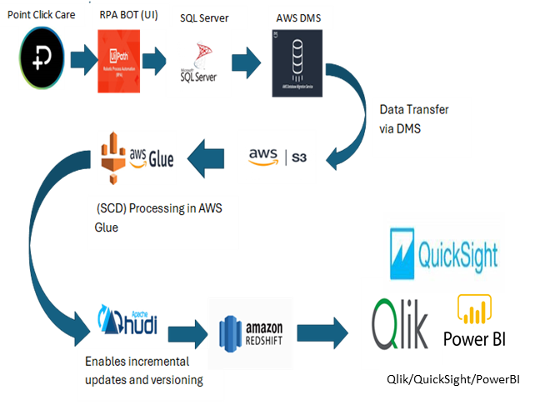
- Tools and Software: SQL Server 2019, RPA UI Path, AWS, QuickSight
- Access and Permissions: Sara to help in enabling access permissions to the PCC backup file. All accesses from Thrivewell on the AWS, QuickSight will be provided on timely basis to BRIO business user as specified.

RACI Matrix for Data Analytics Report
Task | Responsible I | Accountable (A) | Consulted I | Informed (I)
Report Requirement | Nandan Kishore, Sara Wild | Sara Wild | Sara Wild | Marcus Bryan,  Woody Pryor,
Data Extraction | Data Analyst, Data Team | Nandan Kishore | Sara Wild, Marcus Bryan, Nandan Kishore | Sara Wild, Marcus Bryan, Woody Pryor, Data Team
Data Refresh Setup | Sara Wild, Nandan Kishore,  Data Architect | Nandan Kishore | Sara Wild, Nandan Kishore, Data Architect | Sara Wild, Marcus Bryan, Woody Pryor, Data Team
Report Design & Visualization Creation | Business Analyst, Nandan Kishore | Nandan Kishore | Sara Wild, Data Analyst | Sara Wild, Business Users, Data Team
Metrics Definition | Sara Wild, Business User,  Data Analyst | Nandan Kishore | Sara Wild, Nandan Kishore | Sara Wild, Business Users, Data Team
Filter Specification | Sara Wild, Business User | Data Analyst | Data Analyst | Stakeholders
Report Distribution | Sara Wild, Business User | Nandan Kishore | Sara Wild, Nandan Kishore, Data Analyst | Marcus Bryan, Nandan Kishore, Data Analyst
Access Permissions | Sara Wild,  TWT IT Admin Team,  Nandan Kishore, Data Analyst | Sara Wild | Security Managers, Marcus Bryan | Security Managers, Marcus Bryan, Woody Pryor,  Nandan Kishore

Additional Information
- Scope change documentation
- Risk & assumptions will be documented as we progress
- Will introduce a systematic “change management” process

Out of Scope
- Implementation of a new data storage infrastructure
- AI-based automation of decision-making processes

